GENPP502: PYTHON PROGRAMMING

Date: 08th Dec 2025
Period: 08:00AM – 12:00AM

SCHOOL COMPREHENSIVE ASSESSMENT
SECTOR: ICT & MULTIMEDIA
RTQF LEVEL: 5
TRADES: NETWORKING AND INTERNET TECHNOLOGY

100
MARKS:
DURATION: 3 HOURS
INSTRUCTIONS TO CANDIDATES:
- This Exam paper is composed of THREE (3) Sections (A, B and C). Follow the instructions given below, and answer the indicated questions for a total of 100 marks
Section A: Attempt all questions. (55 Marks)
Section B: Attempt THREE (3) in among 4 questions this section. (30marks)
Section C: Attempt one question (1) in among 2 question this section. (15marks)
2. Use only blue pen or black pen.

SECTION A: ANSWER ALL QUESTIONS (55 Marks)

A. FILL IN THE BLANKS (7 Marks)

A. high-level, simplicity
B. store
C. int
D. #
E. if
F. for
G. user-defined function
Marking: 1 mark each

B. MULTIPLE CHOICE QUESTIONS (10 Marks)
- b) Easy to learn and highly readable
- d) decimal
- **b) ** **
- b) while
- c) continue
- a) pip
- a) .py
- b) def myFunc():
- b) list
- b) Repeating tasks automatically
Marking: 1 mark each

C. TRUE/FALSE QUESTIONS (5 Marks)

A. TRUE
B. TRUE
C. TRUE
D. FALSE (Python is interpreted, not compiled)
E. FALSE (tuples are immutable)
Marking: 1 mark each

D. MATCHING QUESTIONS (10 Marks)
Column A | Column B | Answer
1. int | C. A data type for whole numbers | C
2. list | D. Ordered, mutable collection | D
3. def | B. Used to define functions | B
4. pip | A. Used to manage packages | A (corrected from original options)
5. Virtual environment | E. Isolates Python project dependencies | E
6. float | F. Number with decimals | F
7. if statement | G. Used for decision-making | G
8. while loop | H. Repeats based on condition | H
9. break | I. Stops a loop immediately | I
10. continue | J. Skips to the next loop iteration | J
Marking: 1 mark each

E. ORDERING QUESTIONS (5 Marks)
Correct order:
- Check system requirements
- Download Python installer
- Install Python
- Verify installation using python3 –version
- Configure Python virtual environment
Marking: 1 mark each

F. SHORT-ANSWER QUESTIONS (20 Marks)
15. Four benefits of using Python (4 marks, 1 mark each)
- Easy to learn and read
- Cross-platform compatibility
- Large standard library
- Supports multiple programming paradigms
- Rapid development
- High community support
16. Python code to create and print variable age (6 marks)
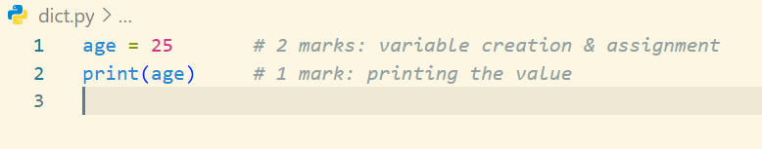
Marks: 2 marks for variable creation & assignment, 1 mark for print, 3 marks for correct syntax
17. Python function greet() with default parameter (5 marks)
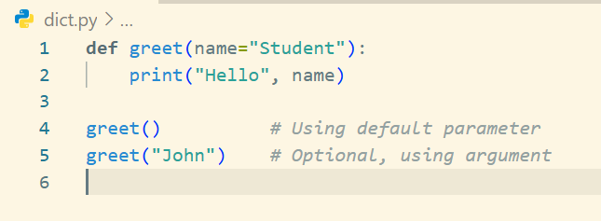
- Function definition correct: 2 marks
- Default parameter used: 1 mark
- Print statement correct: 1 mark
- Function call correct: 1 mark

SECTION B: ANSWER ALL QUESTIONS (30 Marks)
18. Python data types (10 marks)
- int: whole numbers, e.g., x = 5
- float: decimal numbers, e.g., y = 3.14
- str: text enclosed in quotes, e.g., name = "Alice"
- bool: True/False, e.g., flag = True
- list: ordered, mutable collection, e.g., lst = [1,2,3]
- tuple: ordered, immutable collection, e.g., tup = (1,2)
- dict: key-value pairs, e.g., d = {"name":"Alice"}
- set: unordered, unique elements, e.g., s = {1,2,3}
Marking: 1–2 marks per data type with example

19. Python virtual environment steps (10 marks)
- Create: python -m venv env_name ✅
- Activate:
  - Windows: env_name\Scripts\activate
  - Linux/Mac: source env_name/bin/activate
- Use: install packages within environment using pip
- Deactivate: deactivate
Marking: 2–3 marks per step

20. Python control structures (10 marks)
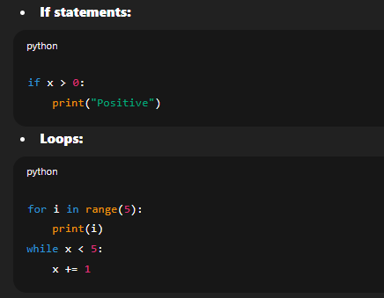
- Jump statements:
  - break ends loop immediately
  - continue skips current iteration
  - pass placeholder
Marking: 2–3 marks per control type with example

21. User-defined functions (10 marks)
- Syntax: def function_name(parameters):
- Default parameters: def greet(name="Student"):
- Function calls: greet() or greet("Alice")
- Example:

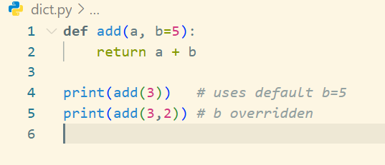

SECTION C: ANSWER ONLY ONE QUESTION (15 Marks)
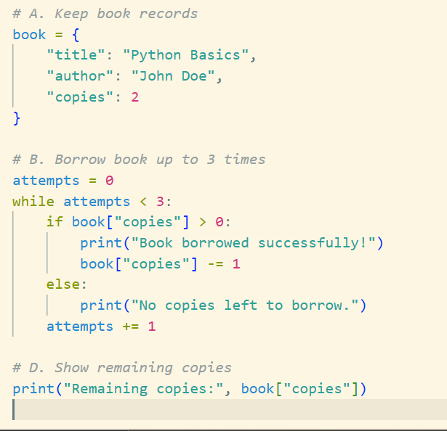
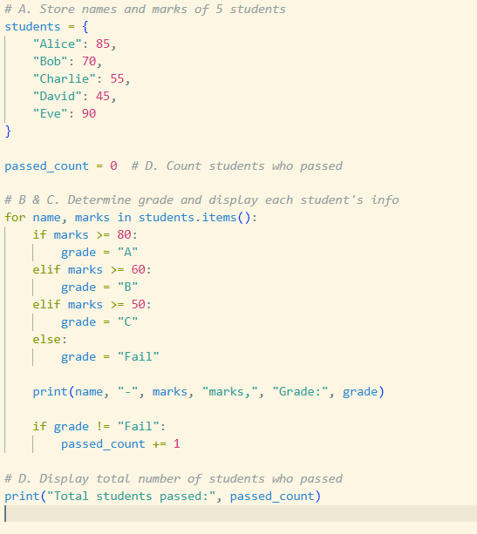
23. 24.

